

**Tobor Inc.**

ToborAutomator

Automating User Registration and Updating Process, Including Sending Aggregated Information to Users on an Interval

Version 1.0

Revision History

|  |  |  |  |
| --- | --- | --- | --- |
| Date Issued | Version | Description | Author |
| *22/06/2020* | *1.0* | *Draft* | *Lukasz Dudek* |
| *23/06/2020* | *1.1* | *Final* | *Lukasz Dudek* |

Contributors

The content of this document has been authored with the combined input of the following group of key individuals.

|  |  |  |
| --- | --- | --- |
| Name | Role | Area |
| *Lukasz Dudek* | *RPA Consultant* | *QAC* |

Business Sign-off

The following table contains the people required to sign-off and/or review this document and those that require the document for information only.

|  |  |  |
| --- | --- | --- |
| Name | Department | Responsibility |
| *David Bradbury* | *Managing Director* | *Sign Off* |
| *Roberto Fernandez* | *Backend Application Manager and Project PM* | *Sign Off* |
| *Chris Lucas* | *Consultant Project Liaison* | *Review* |

Document Classification

|  |  |
| --- | --- |
| Classification | Company Confidential |
| Definition | *Information that the company owns and is responsible for after the user has submitted it* |
| Context | *Where loss of information confidentiality would result in significant harm to the interests of the company, financial loss, embarrassment or loss of information. Including and not limited too legal actions taken against the company, depend on the harm done.* |
|  |  |

Contents

1 Introduction 4

2 Manual Process 4

2.1 Overview 4

2.2 Detailed Process Flow 4

3 Automation Proposal 4

3.1 Overview 4

3.2 Automated Process Flow 4

3.3 Target Systems & User Requirements 4

3.4 Impacted Business Areas 5

3.5 Workload 5

3.6 Operational Constraints 5

3.7 Delivery 5

3.8 Contact List 5

4 Automation Details 6

4.1 Automation Walkthrough 6

4.1.1 *First robot action* 6

4.1.2 *second robot action* 6

4.1.3 *third robot action etc.* 6

4.2 Reporting 6

4.2.1 Business Exceptions 6

4.2.2 System Exceptions 6

4.2.3 Performance 7

4.2.4 Triggers 8

# 1 Introduction

With the successful launch of a new Application made by Tobor Inc. They have seen a significant increase in users registering and using the application. The process takes 1 Manager approximately 50% of there time each day, to sort through registrations, move them to a database and then send out the correct information to clients. While doing that, all materials send are also scanned and checked to ensure they are legible and have clear connect, including but not limited to ensuring no content is repeated. Automating this process would not only give the manager more time to work on other aspects of the growing business but also reduce the human error in things like checking past information sent or ensuring the content is clean.

Additionally, to the information above, there should be a report produced each day with information and details of what was send that day. Mentioned in the specification that it is not always done as there is a time constraint, making this a robotic task would ensure it is always done and stored in a secure location for archiving porpoises and audits.

# 2 Manual Process

## 2.1 Overview

*The process is triggered every time a user registers on the System before the cut off time. Backend Application Manager deals with the Email accordantly to the request and sends out the information to the correct people are the specific intervals:*

* Users’ needs to register before they will receive the aggregated information
  + User must send an Emails to the Company’s Email Address with the following information: Users First Name, Last Name, Address and Topic of interest for the information.
* On receipt of the user’s information, the company stores the data safely
* Once the user’s information has been processed, the request is filled accordingly
* The actions are recorded to measure the app growth
* After the users is sent a confirmation email
* Based on users’ preferences, content is aggregated from a minimum of 3 sites
* Manager ensure that there is no repeat content
* Content that is sent, is read and ensured it is clean and readable
* Content is separated into categories, specified by the company
* Content is sent from the Company direct to the user’s email address
* All users’ actions are recorded for Audit purposes
* Managers record several items against all content transmissions (Example, User’s name and the date)
* A daily report is sent as a PDF, via email to the Company and stored in a local folder

## 2.2 Detailed Process Flow

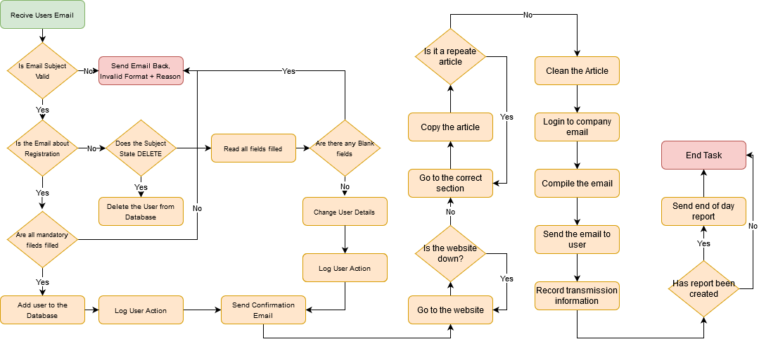

# 3 Automation Proposal

## 3.1 Overview

The details supplied of the manual process shows a full end-to-end process in one.

QA Ltd proposes to automate all sections of the manual process - providing 2 processes opposing to 1. Process 1 running on 5-minute intervals assigned to a dynamic robot dealing with Emails sign ups, ensuring all Emails are dealt with a timely manner. Process 2 running on a Scheduled task at 11:30am which would ensure all users who are registered/changed their details would receive their information at a specific time and it will exclude any new sign ups after 11:30am.

Details process are shown below:

Process 1 (Email Responder [Interval: 5 Minutes])

* Checks for Unread Emails
* Validated the Title
* Create/Edit user details
* Sends confirmation email
* Logs user’s activity
* Archives email

Process 2 (Data Responder [Scheduled: 11:30AM])

* Get all people in database
* Add people with correct interval to the queue
* Go to website to gather articles
* Each article is checked, and extra info is removed
* Article is saved on a local folder
* Article is checked against older articles saved
* Configuration file is updated with article saved location
* Get Users in queue
* Send out the saved articles in the pre-set format through email
* Log the bot action if successful or not
* Log the bot action in excel file named report_DATE.xlsx
* Construct end of day report
* Attach Excel file named report_DATE.xlsx
* Send it to Company Email and transfer it to an archive folder
* End Process

## 3.2 Automated Process Flow

*The automated process will follow the manual process with minor changes to support an extensive logging system and split into 2 different processes like shown above. A new Process Flow Diagram has been attached below, showcasing the 2 process.*

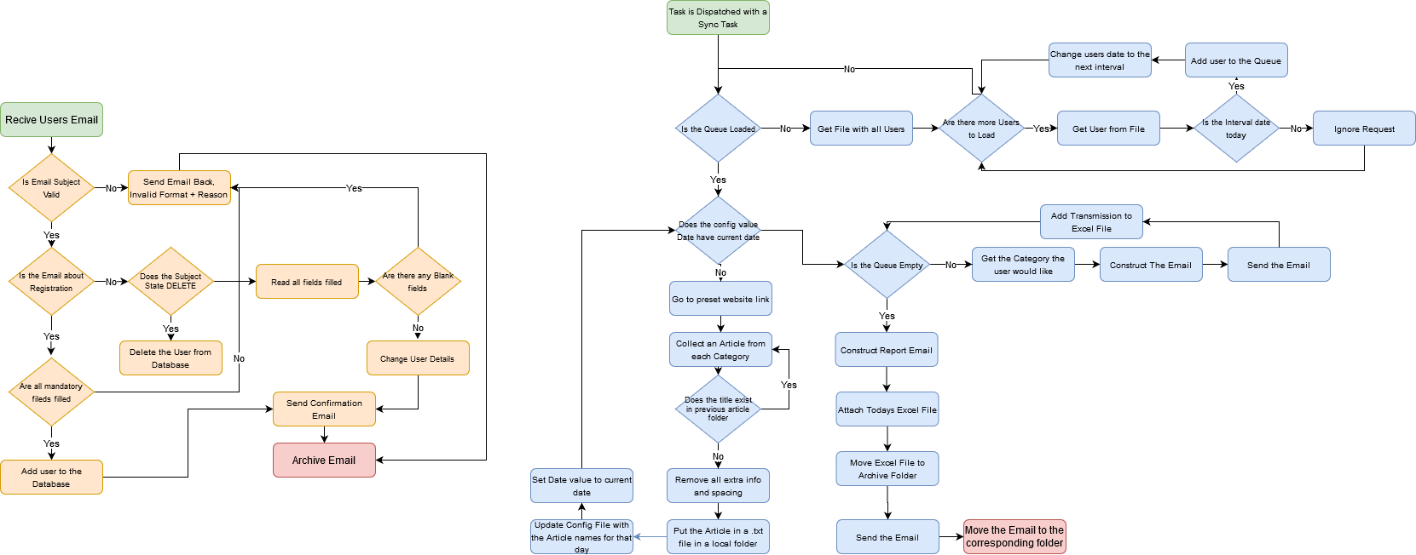

## 3.3 Target Systems & User Requirements

| Name | Description | User Permissions/Access |
| --- | --- | --- |
| *MS Outlook* | *Emails Access* | *ToborAutomator requires access to Company’s email inbox* |
| *Database* | *Customer Information Database* | *Administration Permissions* |
|  |  |  |

## 3.4 Impacted Business Areas

* Backend Application Department

## 3.5 Workload

Metrics related to the automation

|  |  |
| --- | --- |
| Max. no. of requests dealt with | Restricted to Server capability |
| Min. no. of requests dealt with | Restricted to Server capability |
| Are there any periods when a higher workload is anticipated? | Big Media Events and Big Sport Events |
| How many people do this process per day? | 1 |

***On average it takes about 15 minutes (0.25 hrs) per user to register them or change details. Sending out the information to the users takes, on average 240 minutes (4 hrs).***

***Automating the steps below will realise an average time saving of 390 minutes (6.5 hrs) per day for ToborAutomator:***

* Login to Email Service (5 mins)
* Deal with User Email Request (10 mins)
* Aggregate Articles (45 mins)
* Check against old Articles (30 mins)
* Construct the emails (120 mins)
* Send the email to client (30 mins)
* Add users to report (15 mins)

## 3.6 Operational Constraints

* Websites used to aggregate the information
* Email services
* Network speeds available to aggregate the information

## 3.7 Delivery

The project is delivery is set to be due on Friday 26th of June 2020.

## 3.8 Contact List

Managing Director - David Bradbury

Backend Application Manager and Project PM - Roberto Fernandez

Consultant Project Liaison – Chris Lucas

RPA Consultant – Lukasz Dudek

# 4 Automation Details

## 4.1 Automation Walkthrough – process 1 (user registration/detail change)

### 4.1.1 read through all unread emails

* Go to main inbox and read the information

### 4.1.2 validated email and respond ACCORDINGLY

* Check the Subject Name
  + Is the subject name REGISTRATION, DELETE or CHANGE?
    - If it is not, send an email with according error. Flag Process as Business Exception
  + Continue with the request

### 4.1.3 Respond to the request

* Get the Request – REGISTRATION

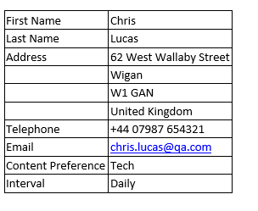

* + Ensure all fields are filled correctly
    - If fields are blank, send an email with according error. Flag Process as Business Exception
  + Check if Users email exists in database
    - If user exists, send an email with according error. Flag Process as Business Exception
  + Add the user to the Excel database
  + Send user confirmation email
  + Add user registration to Report Log.
  + Archive the Email under “Registration Request Archive”
* Get the Request – CHANGE
  + Ensure fields are not blank
    - If fields are blank, send an email with according error. Flag Process as Business Exception
  + Change user details to updated information
  + Send user confirmation Email
  + Add user detail change to Report Log.
  + Archive the Email Under “Change Request Archive”
* Get the Request – DELETE
  + Check if the email exists in Excel database
    - If the user does not exist, send an email with according error. Flag process as Business Exception
  + Remove the user from Excel database
  + Send user confirmation Email
  + Add user deletion to Report Log
  + Archive the Email under “Delete Request Archive”

## 4.2 automation walkthrough – process 2 (content aggregation and reporting)

##### 4.2.1 load the queue

* Check if the Queue is loaded
  + If queue is not loaded do
    - Get users database
    - Get every user from database
    - Check article date column
      * If date is current date – add the queue with article category
      * Else ignore user and move to next
    - If no more users, exit task
  + Else move to next task

##### 4.2.2 aggregate information

* Does the configuration file have current date?
  + If no, articles need to be aggregated
    - Go to specified website
      * Type in specific search term in category
      * Do any articles pop up?
        + Yes, go to the article

Clean out the article, ensuring all unnecessary information is removed

Collect the information and save it to a .txt file

Add path location to a configuration file

Move to next article

* + - * + No, try again

If no result persists, move to next article

Throw System Error

* + - Repeat process for all websites and categories
  + Else move to next activity

##### 4.2.3 construct emails and send

* Get a user from the queue
  + Get the category the user requested
  + Collect the 3 articles saved locally
  + Create an email to the user
  + Put the subject of email pre-set in config
  + Type the articles aggregated inside the email
  + Send the email out
  + Log the transmission into an excel file
* When queue is empty, move to next task

##### 4.2.4 report

* Create a new email
  + Put the subject as “Daily Report DATE”
    - Replacing DATE with current date (excluding time)
  + Attach the Excel Report to the email
  + Move the Excel report to archived folder
  + Send the Email to the desired person

## 4.2 Reporting

### 4.2.1 Business Exceptions

|  |  |
| --- | --- |
| Exception | Solution |
| Incorrect Email Subject | Internal System to check subject lines. Throw exception, send user email back with error message. |
| Empty Field on Registration | Internal System to check fields, throw exception, send user email back with error message. |
| All Fields Empty on User Change Details | Internal System to check, throw exception, send user email back with error message |
|  |  |
|  |  |
|  |  |

### 4.2.2 System Exceptions

|  |  |
| --- | --- |
| Exception | Solution |
| *Website down* | *Robot would skip the article, throw exception, send Critical Email to System Administration Email* |
| *Network down* | *Robot would be unavailable to obtain information, throw exception, send Critical Email to System Administration Email* |
| *Website not found* | *Robot would skip the article, throw exception, send Critical Email to System Administration Email* |
| *Invalid Email Entry* | *Robot uses a filtering system to ensure email is in valid format. Potential error still can occur* |
| *Date Incorrectly Formatted* | *Robot uses the same DateTime format across all aspects of automation to minimize the risk of invalid format* |

A performance report will be emailed to company email each time the process runs (showing worked cases, exceptions and a cumulative processing log)

### 4.2.3 Performance

Once the processes 2 has been completed, it will compile the cumulative report of Process 1 and Process 2 and send it off as a report. Data will be constructed into an Excel file with 2 Sheets.

**Performance Report**

This will contain all exceptions (business and system) and successes for the automated Process, based on the last automation execution completion (i.e. based on the last time the process ran)

EXAMPLE REPORT

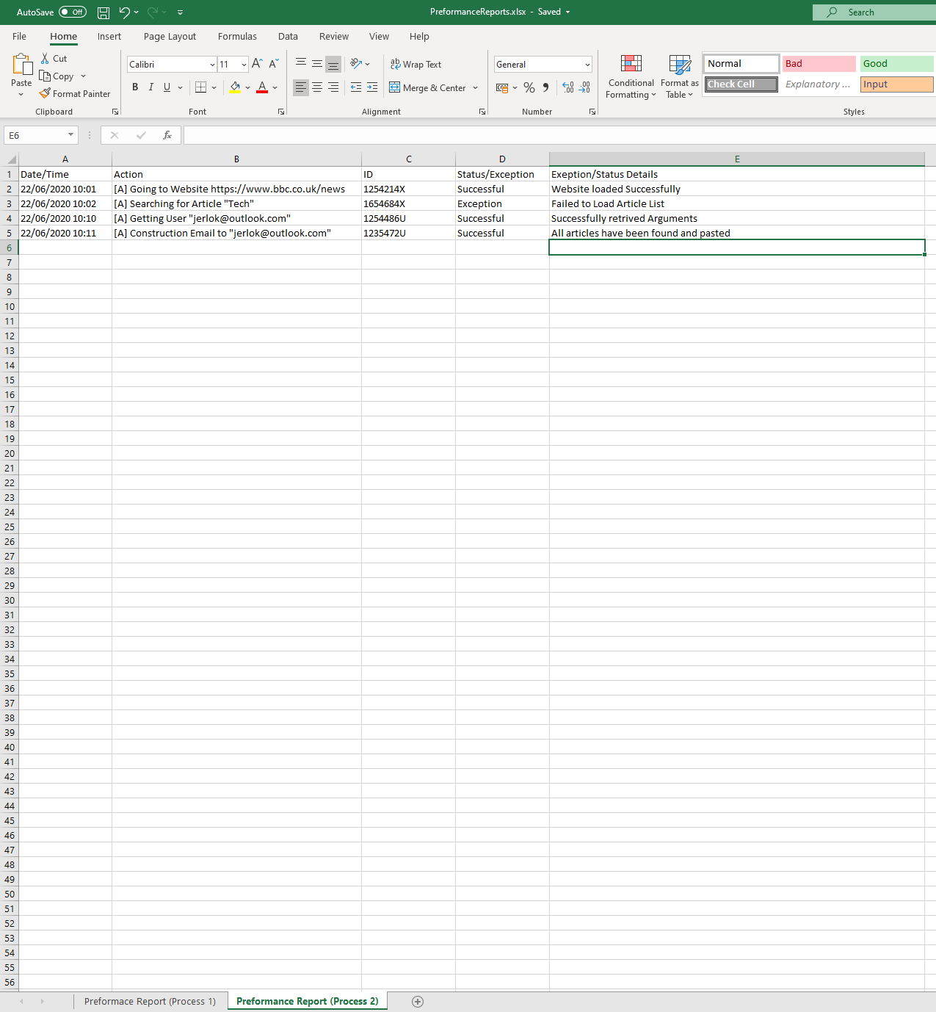

### 4.2.4 Triggers

The robot utilised in this automation will be unattended. As explained above, process 1 will run on an interval of 5 minutes to ensure a timely response to client. Process 2 will be a scheduled task at 11:30am which is the cut-off time for new registration, meaning all users registered prior and users previously registered will receive their aggregated information past 11:30am.